Your Name |  | Lauren Mazzoli
Step / Points |  | Put your answers for each question below in this column. Be sure to follow the instructions on making screen shots.  Note that the cells below set to double space. Please don’t change that!
1 | 10 | 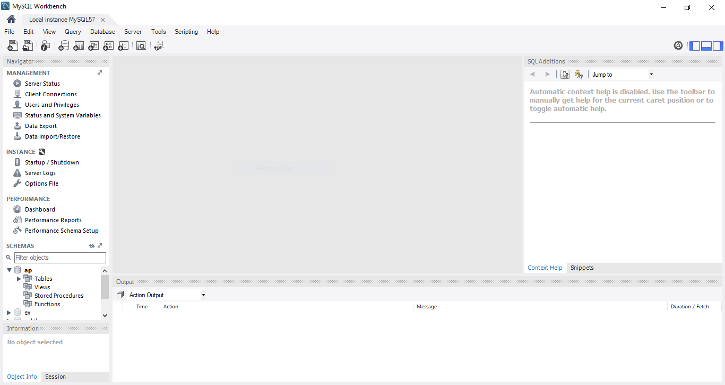  Installing MySQL didn’t go smoothly the first time I tried it. . I stopped tried to download the items that were marked as needing manual attention. Hence, I download for ConnectorPython and install that before proceeding with the MySQL install. It still errored again after installing Python because I installed a later version than the installer required. I decided to proceed anyway, according to the instructions. Next, the applications all downloaded and attempted to install. Many of them errored out and despite retrying each one, they would not install without errors. I decided to cancel the installation application and start again after some rest. A few days later, I tried again. I read all instructions, downloaded the software again, printed the Powerpoint guide and read the blackboard comments, Then I executed the installer and removed everything that had been installed. I followed the Powerpoint steps and skipped the python download. This time only two applications had errors. Upon patiently retrying them, they were installed successfully. Next, an extra window popped up in my newer version of MySQL Installer to ask if I wanted to install MySQL s a Document Store. I skipped this extra step and the rest of the install proceeded without incident. .
2.1 | 10 | 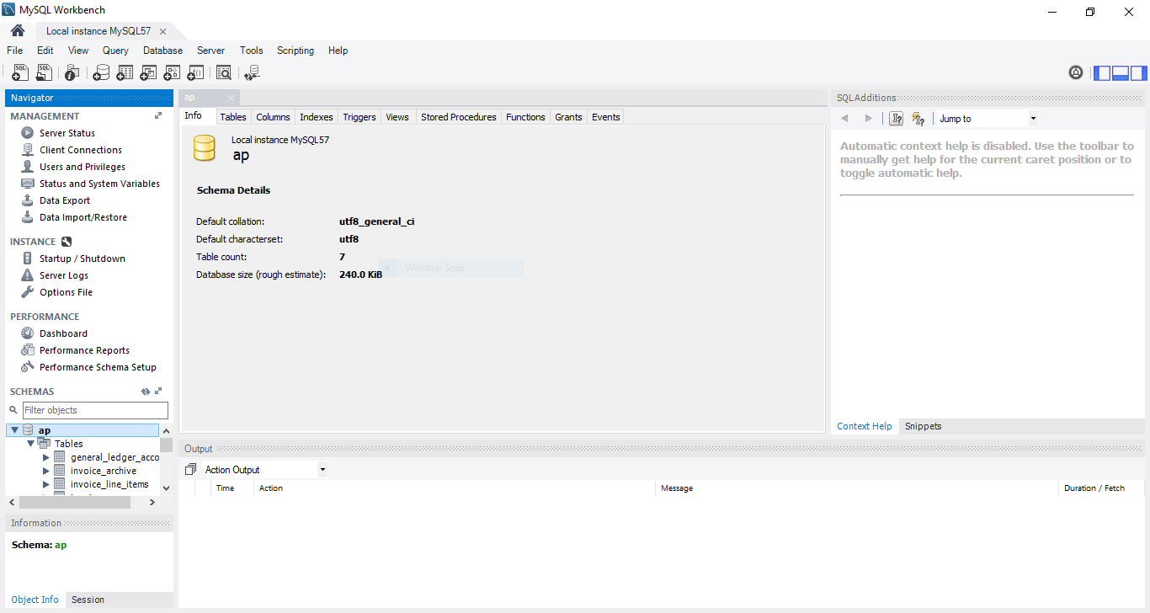
2.2 | 10 | It was not very clear to me from the directions how to upload the script file from blackboard into MySQL Workbench. At first, I clicke don the downloaded script file and chose open with MySQL Workbench. The application opened and the connection was made but it put the code into a window where I was unable to execute it. I started over by closing and opening the application again and then closing the file to open. The first time I tried, I was able to make the connection. I exited the software opened it again and clicked on File>Open new script. This worked flawlessly for both files and I was able to execute them with no issues. Upon schema refresh, the ap database was uploaded as you can see in the snippet above.
3.1 | 5
  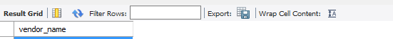
  American Booksellers Assoc
  American Express
  ASC Signs
  Ascom Hasler Mailing Systems
  AT&T
  Aztek Label
  Baker & Taylor Books
  Bertelsmann Industry Svcs. Inc
  BFI Industries
  Bill Jones
  Bill Marvin Electric Inc
  Blanchard & Johnson Associates
  Blue Cross
  Blue Shield of California
  Boucher Communications Inc
  Cahners Publishing Company
  Cal State Termite
  California Business Machines
  California Chamber Of Commerce
  California Data Marketing
  Capital Resource Credit
  Cardinal Business Media, Inc.
  Champion Printing Company
  City Of Fresno
  Cmg Information Services
  Coffee Break Service
  Compuserve
  Computer Library
  Computerworld
  Control Data Coporation
  Costco
  Courier Companies, Inc
  Crown Printing
  Custom Printing Company
  Data Reproductions Corp
  Dataforms/West
  Dean Witter Reynolds
  Digital Dreamworks
  Diversified Printing & Pub
  DMV Renewal
  Dristas Groom & McCormick
  Edward Data Services
  Enterprise Communications Inc
  Evans Executone Inc
  Executive Office Products
  Expedata Inc
  Federal Express Corporation
  Ford Motor Credit Company
  Franchise Tax Board
  Frank E Wilber Co
  Fresno County Tax Collector
  Fresno Credit Bureau
  Fresno Photoengraving Company
  Fresno Rack & Shelving Inc
  Gary McKeighan Insurance
  Golden Eagle Insurance Co
  Gostanian General Building
  Graylift
  IBM
  Ingram
  Internal Revenue Service
  Jobtrak
  Kent H Landsberg Co
  Leslie Company
  Lou Gentile's Flower Basket
  Malloy Lithographing Inc
  Mcgraw Hill Companies
  McKesson Water Products
  Micro Center
  Nat Assoc of College Stores
  Naylor Publications Inc
  Net Asset, Llc
  Newbrige Book Clubs
  Nielson
  Office Depot
  Opamp Technical Books
  Open Horizons Publishing
  Pacific Bell
  Pacific Gas & Electric
  Ph Photographic Services
  Pollstar
  Postmaster
  Publishers Marketing Assoc
  Publishers Weekly
  Quality Education Data
  Register of Copyrights
  Reiter's Scientific & Pro Books
  Retirement Plan Consultants
  Rich Advertising
  Roadway Package System, Inc
  Robbins Mobile Lock And Key
  RR Bowker
  Shields Design
  Simon Direct Inc
  Small Press
  Springhouse Corp
  State Board Of Equalization
  State of California
  Suburban Propane
  Texaco
  The Drawing Board
  The Fresno Bee
  The Library Ltd
  The Mailers Guide Co
  The Presort Center
  The Windows Deck
  Towne Advertiser's Mailing Svcs
  United Parcel Service
  Unocal
  US Postal Service
  Valprint
  Venture Communications Int'l
  Vision Envelope & Printing
  Wakefield Co
  Wang Laboratories, Inc.
  Wells Fargo Bank
  Yale Industrial Trucks-Fresno
  Yesmed, Inc
  Zee Medical Service Co
  Zip Print & Copy Center
  Zylka Design
3.2 | 5 | 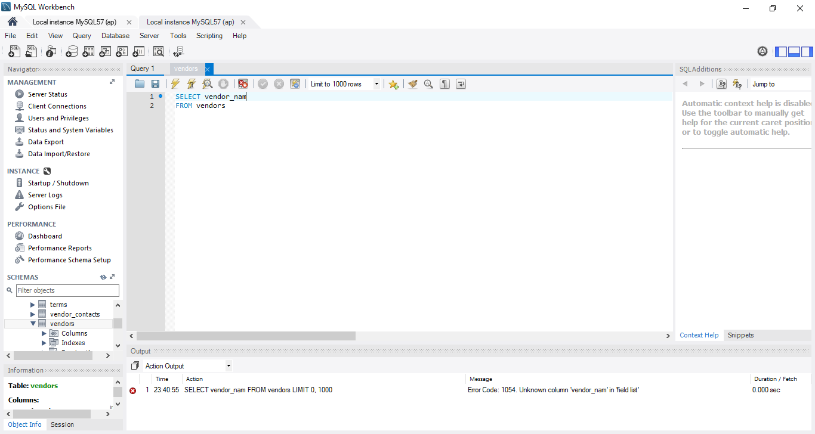
3.3 | 5 | Server errors start with “10”. Error 1054 means that the column name given is unknown. This means that it does not exist on the table name given in the select statement. To resolve the issue, double check the correct spelling of the column-name and also check to be sure you are referencing the correct table in the correct database.
3.4 | 5 | The MySQL Workbench is a fairly intuitive product. The assignment was not difficult to implement. I read Chapter 2 prior to implementing the software. Going back over chapter 2 now that I have installed the software and following along to emulate the functions as they are described will enable me to gain a better grasp on how to use this software and better feel for maneuvering through the various functions to be able to handle more complex assignments and projects in the future.
 | 25 | Total

